**Introduction to Computer**

**And its Basic parts**

**LAB: 01**



**Fall-21**

[**CSE-102L Computer Fundamental Lab**](https://classroom.google.com/u/2/c/MzA5OTAwMDgwMjI2)

Submitted by: **Amir Suliman**

Registration No: **19PWCSE1805**

Class Section: **B**

“On my honor, as student of University of Engineering and Technology, I have neither given nor received unauthorized assistance on this academic work.”

Student Signature: ______________

Submitted to:

**Engr. Abdullah Hamid**

March 18, 2022

Department of Computer Systems Engineering

University of Engineering and Technology, Peshawar

**Objectives:**

* know about computers
* know about processors
* know about different parts of processors
* know about storage devices

**Computer:**

A **computer** is an electronic device that manipulates information or data. It has the ability to store, retrieve, and process data.

**Processor:**

A processor also called a Central Processing Unit (CPU) is an integrated electronic circuit that performs the calculations that run a computer. A processor performs arithmetical, logical, input/output (I/O), and other basic instructions that are passed from an operating system (OS). Most other processes are dependent on the operations of a processor.

**Parts of CPU:**

The following are the main parts of a processor.

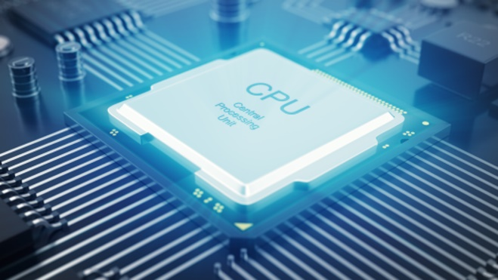

1. Arithmetic Logic Unit (ALU).
2. Control Unit.
3. Registers.

**Intel processors:**

**Intel Core** is a streamlined midrange consumer, workstation, and enthusiast computer [central processing units](https://en.wikipedia.org/wiki/Central_processing_unit) (CPUs) marketed by [Intel Corporation](https://en.wikipedia.org/wiki/Intel). These processors displaced the existing mid-to-high-end [Pentium](https://en.wikipedia.org/wiki/Pentium) processors at the time of their introduction, moving the Pentium to the entry-level. Identical or more capable versions of Core processors are also sold as [Xeon](https://en.wikipedia.org/wiki/Xeon) processors for the server and workstation markets

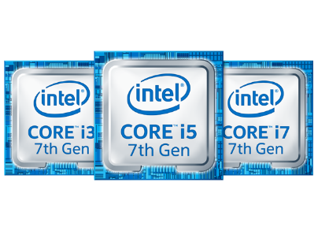

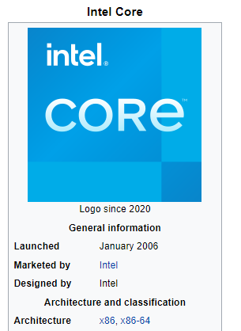

**Intel Pentium processors:**

**Pentium**, family of [microprocessors](https://www.britannica.com/technology/microprocessor) developed by [Intel Corp](https://www.britannica.com/topic/Intel). Introduced in 1993 as the successor to Intel’s 80486 [microprocessor](https://www.britannica.com/technology/microprocessor), the Pentium contained two processors on a single [chip](https://www.britannica.com/technology/integrated-circuit) and about 3.3 million [transistors](https://www.britannica.com/technology/transistor).

**Intel Xeon processors :**

**Xeon** is a brand of [x86](https://en.wikipedia.org/wiki/X86) [microprocessors](https://en.wikipedia.org/wiki/Microprocessor) designed, manufactured, and marketed by [Intel](https://en.wikipedia.org/wiki/Intel), targeted at the non-consumer [workstation](https://en.wikipedia.org/wiki/Workstation), [server](https://en.wikipedia.org/wiki/Server_(computing)), and [embedded system](https://en.wikipedia.org/wiki/Embedded_system) markets. It was introduced in June 1998. Xeon processors are based on the same architecture as regular desktop-grade CPUs, but have advanced features such as support for [ECC memory](https://en.wikipedia.org/wiki/ECC_memory), higher [core](https://en.wikipedia.org/wiki/CPU_core) counts, more [PCI Express](https://en.wikipedia.org/wiki/PCI_Express) lanes, support for larger amounts of RAM, larger [cache memory](https://en.wikipedia.org/wiki/Cache_memory) and extra provision for enterprise-grade [reliability, availability and serviceability](https://en.wikipedia.org/wiki/Reliability,_availability_and_serviceability) (RAS) features responsible for handling hardware exceptions through the [Machine Check Architecture](https://en.wikipedia.org/wiki/Machine_Check_Architecture).

**Intel core processor family:**

1. Core X-series
2. Core i9
3. Core i7
4. Core i5
5. Core i3

**Storage Devices:**

The storage device typically enables a user to store large amounts of data in a relatively small physical space and makes sharing that information with others easy. The device may be capable of holding the data either temporarily or permanently.

Following are different storage devices.

1. 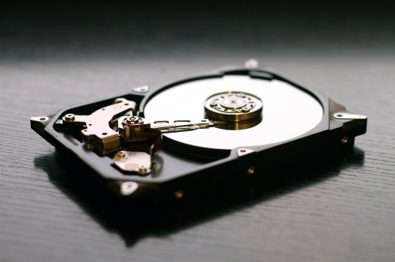**Hard Drive Disks**

A hard disk drive (also known as a hard drive, HD, or HDD) can be found installed in almost every desktop and laptop computer. It stores files for the operating system and software programs as well as user documents, such as photographs, text files, videos, and audio. The hard drive uses magnetic storage to record and retrieve digital information to and from one or more fast-spinning disks.

1. **Floppy Disks**

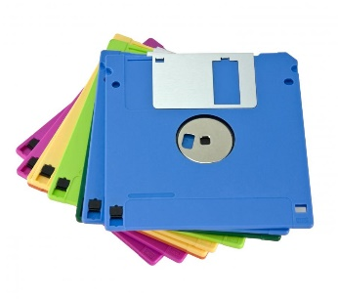 Also know as a diskette, floppy, or FD, the floppy disk is another type of storage medium that uses magnetic storage technology to store information.

The earliest floppies were 8 inches (203 mm) in size, but these were replaced first by 5.25-inch (133 mm) disk drives and finally by ​3.5-inch (90 mm) versions.

1. **Tapes**

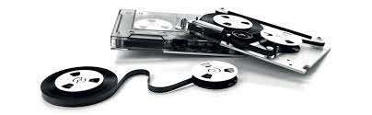 The technology essentially consisted of a thin, magnetically coated piece of plastic wrapped around wheels. Its relative slowness and unreliability compared to other data storage solutions have resulted in it now being largely abandoned as a storage medium.

1. **Compact Discs (CDs)**

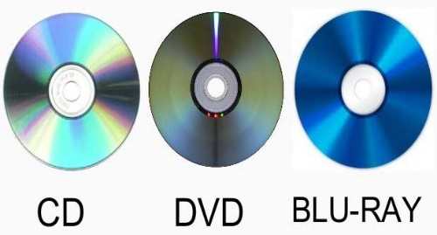 The compact disc, (or CD for short) is a form of optical storage, a technology that employs lasers and lights to read and write data. Initially, compact discs were used purely for music, but in the late 1980s, they began to be used for computer data storage. Initially, the compact discs that were introduced were CD-ROMs (read-only), but these were followed by CD-Rs (writable compact discs) and CD-RWs (rewritable compact discs).

1. **DVD and Blu-ray Discs**

The DVD (digital versatile disc) and Blu-ray disc (BD) are formats of digital optical disc data storage which have superseded compact discs, mainly because of their much greater storage capacity.

A Blu-ray disc, for example, can store 25 GB (gigabytes) of data on a single-layer disc and 50 GB on a dual-layer disc. In comparison, a standard CD is the same physical size, but only holds 700 MB (megabytes) of digital data.

1. **USB Flash Drives**

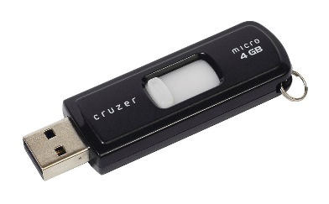 Also known as a thumb drive, pen drive, flash drive, memory stick, jump drive, and USB stick, the USB flash drive is a flash-memory data-storage device that incorporates an integrated USB interface. Flash memory is generally more efficient and reliable than optical media, being smaller, faster, and possessing much greater storage capacity. Flash drives are also more durable due to a lack of moving parts.

1. **Secure Digital Cards (SD Card)s**

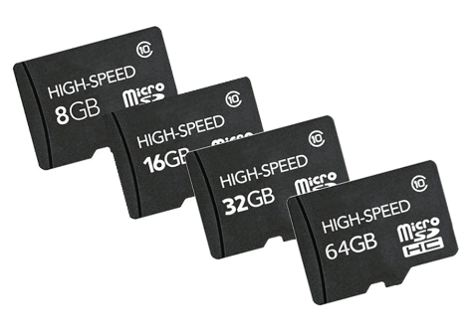 SD cards are commonly used in multiple electronic devices, including digital cameras and mobile phones. Although there are different sizes, classes, and capacities available, they all use a rectangular design with one side “chipped off” to prevent the card from being inserted into a camera or computer the wrong way.

1. **Solid-State Drives (SSDs)**

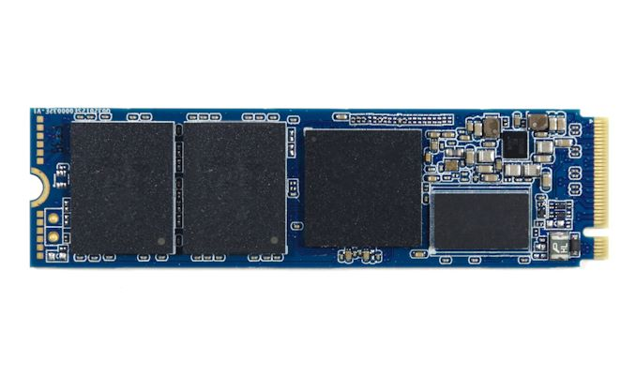 A solid-state drive uses flash memory to store data and is sometimes used in devices such as netbooks, laptops, and desktop computers instead of a traditional hard disk drive.The advantages of an SSD over an HDD include a faster read/write speed, noiseless operation, greater reliability, and lower power consumption. The biggest downside is cost, with an SSD offering lower capacity than an equivalently priced HDD.

1. **Cloud Storage**

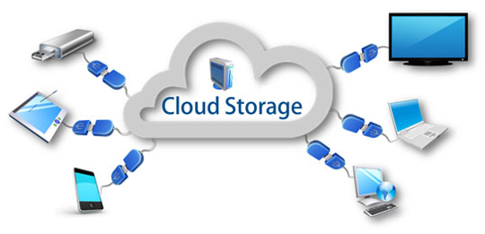 With users increasingly operating multiple devices in multiple places, many are adopting online cloud-computing solutions. Cloud computing basically involves accessing services over a network via a collection of remote servers.

Although the idea of a “cloud of computers” may sound rather abstract to those unfamiliar with this metaphorical concept, in practice, it can provide powerful storage solutions for devices that are connected to the internet.

1. **Punch Cards**

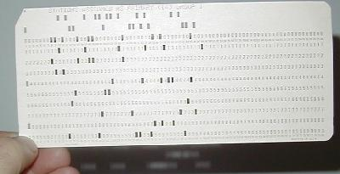 Punch cards (or punched cards) were a common method of data storage used with early computers. Basically, they consisted of a paper card with punched or perforated holes created by hand or machine. The cards were entered into computers to enable the storage and accessing of information.

**End**